Setup intellij with gitlab (sync from remote repository):

* Start IntelliJ and go to VCS -> Checkout from version control -> Git

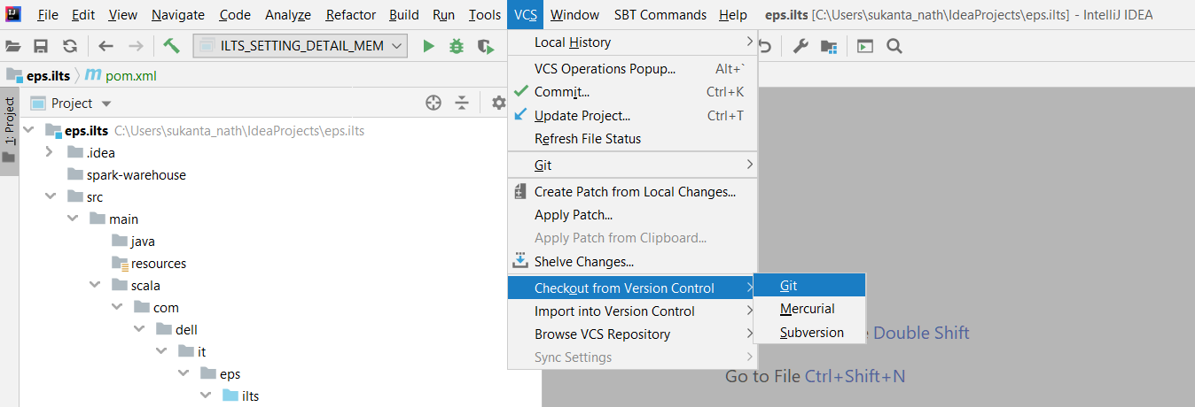

* Following pop-up will come-

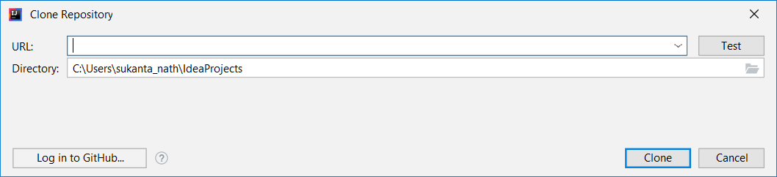

* Go to gitlab.dell.com and select the project you are part of. In our case it is ILTS_SPARK.
* In the project home page select clone -> clone with HTTPS option and copy the link given by gitlab.

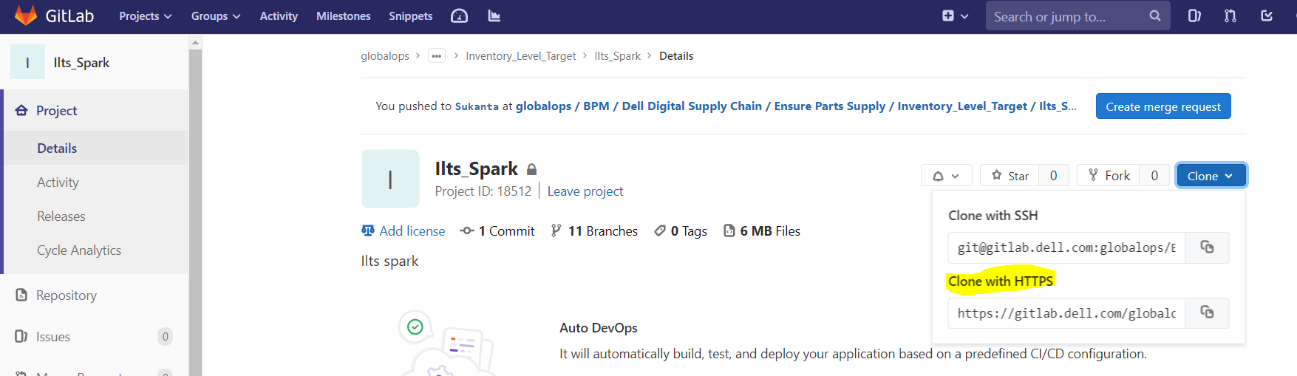

* Paste the same link in IntelliJ pop-up window in URL box. Select directory as per your choice. We are going to create a new one for this demo purpose.

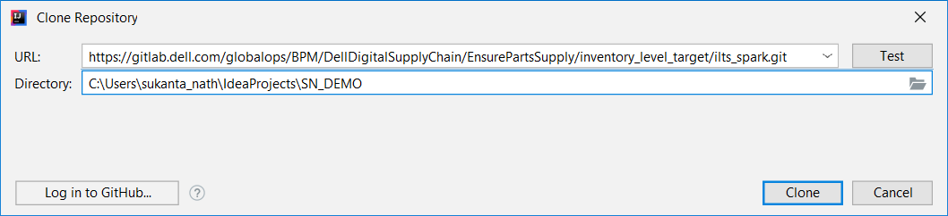

I created new folder SN_DEMO

Click on Test button, it should show Test successful –

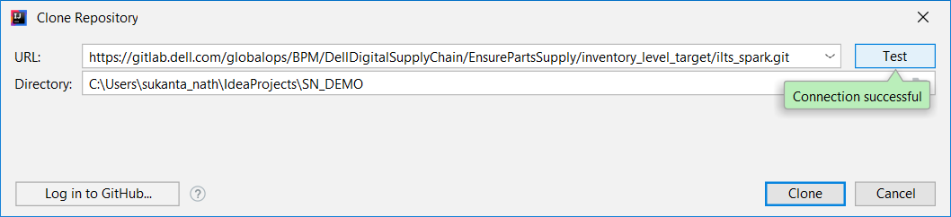

* Now click clone. It’ll take some time to clone. After successful cloning following question will pop-up. Choose “yes”

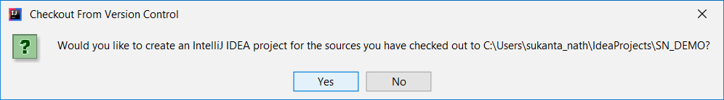

Proceed by selecting following options –

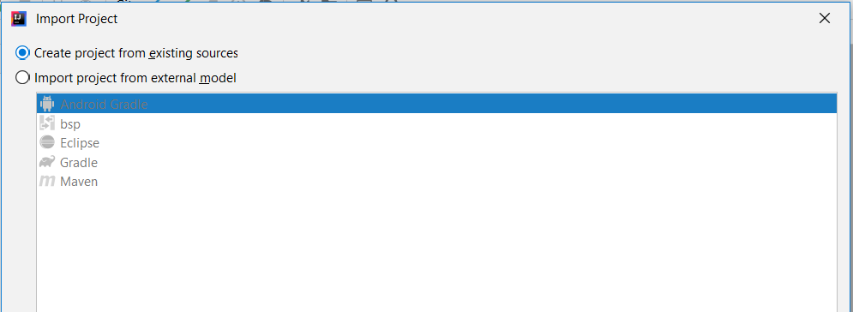

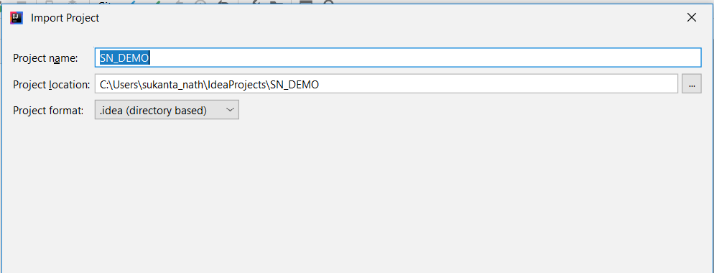

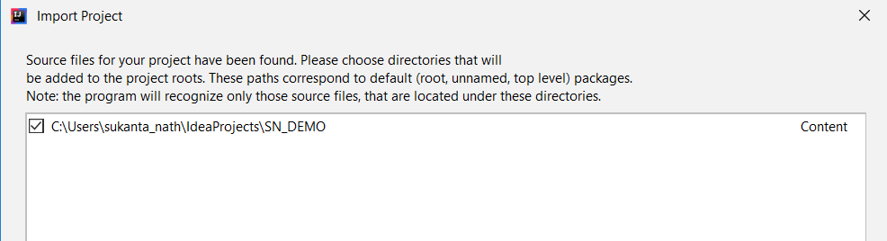

Choose finish and say “New Window” to following question.

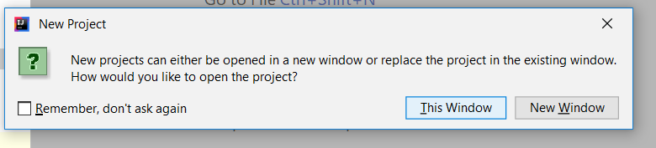

* New project window will look like this –

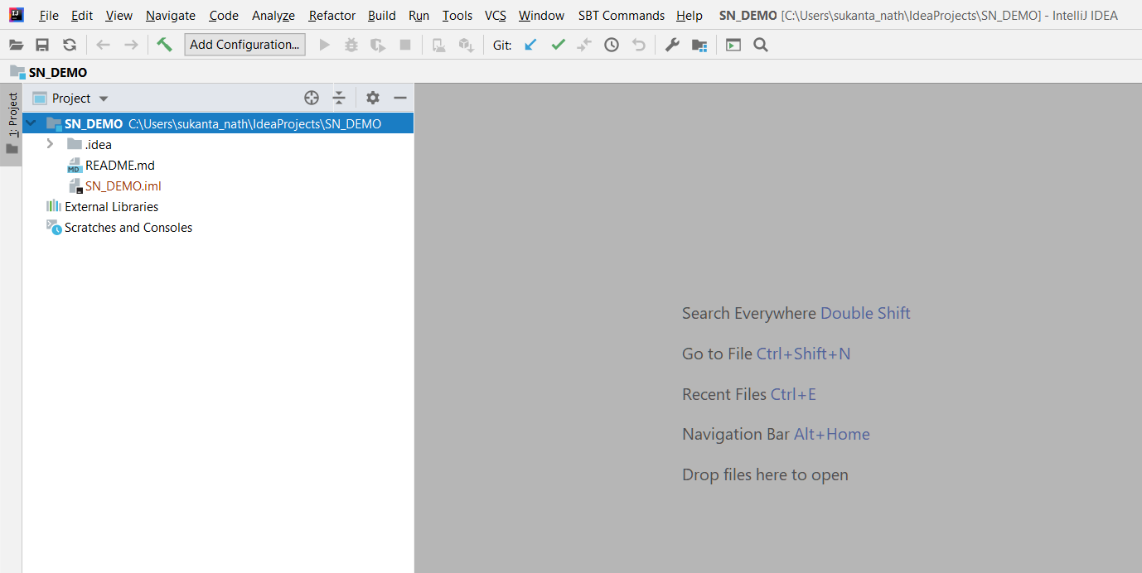

* Now, we have to pull the branch from remote repository (GitLab) where actual code resides.

In this case it is a branch in my name(Sukanta) in gitlab-

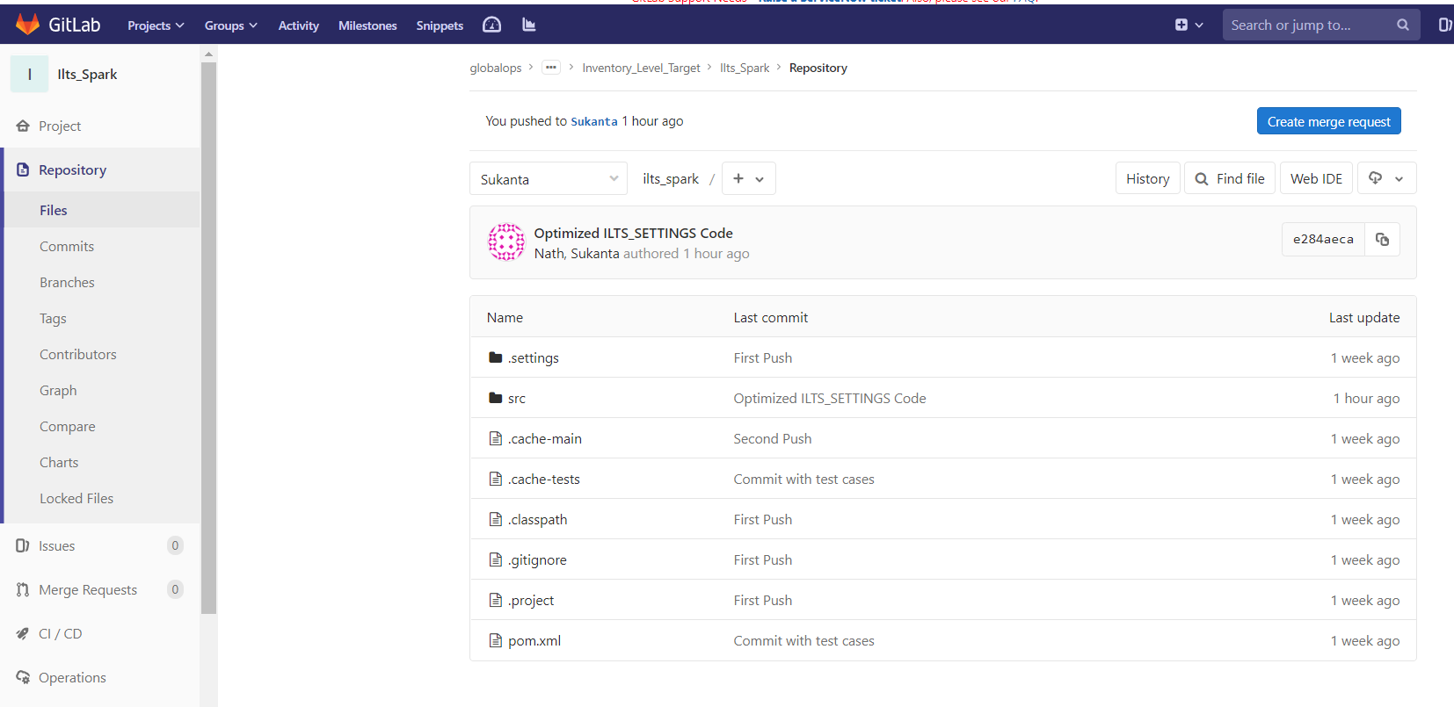

* Let’s clone this in local repository and start modifying –
* Right Click Project -> Git -> Repository -> Branches

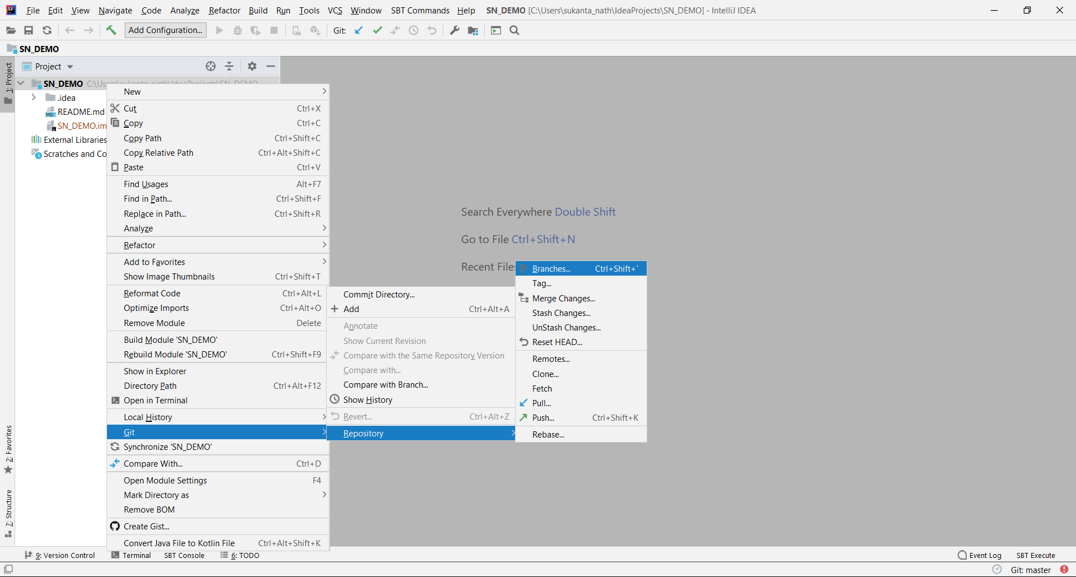

Branches will show both remote and local branches. We’ll select the one we are trying to clone here ,i.e. , origin/Sukanta and click on the option **check out as**

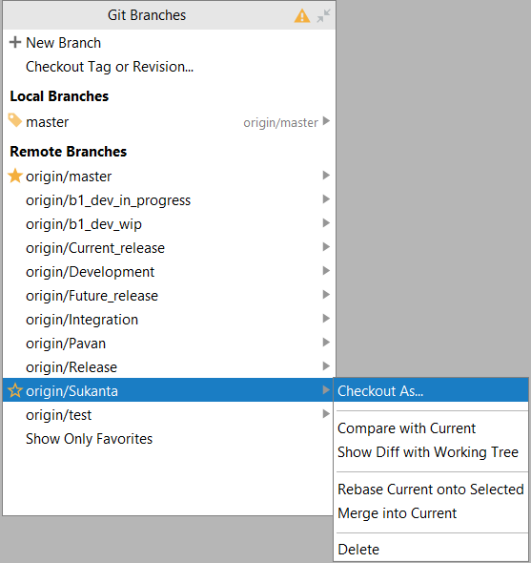

I’ll give local branch name as Sukanta_1

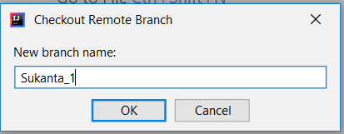

* And it is synced !

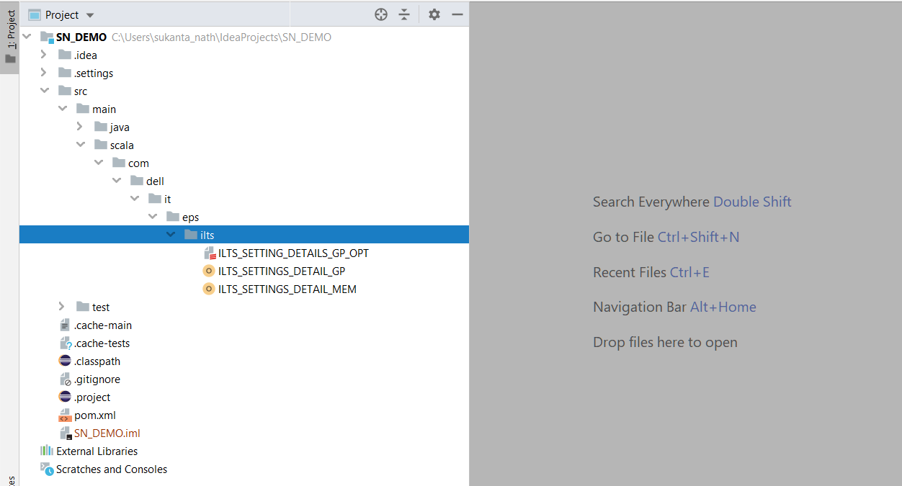

* Now, if we select any code, we don’t see Run option, because though imported, intellij is missing some important configuration to identify it as a scala+maven project. Follow steps mentioned below.

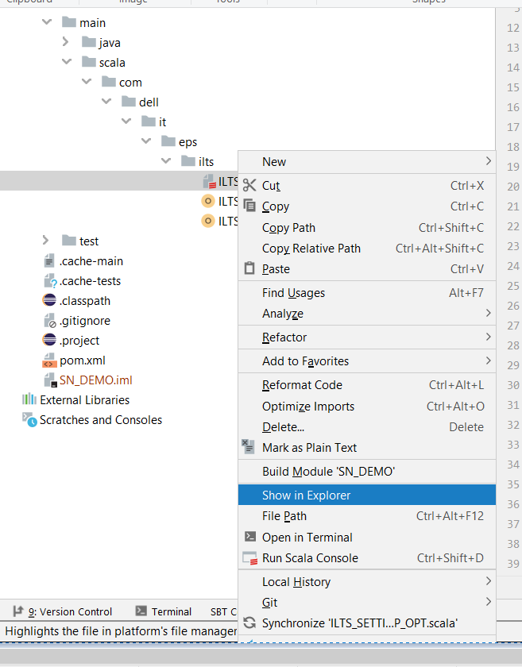(no run option)

* Right click on pom.xml and select add as a maven project.

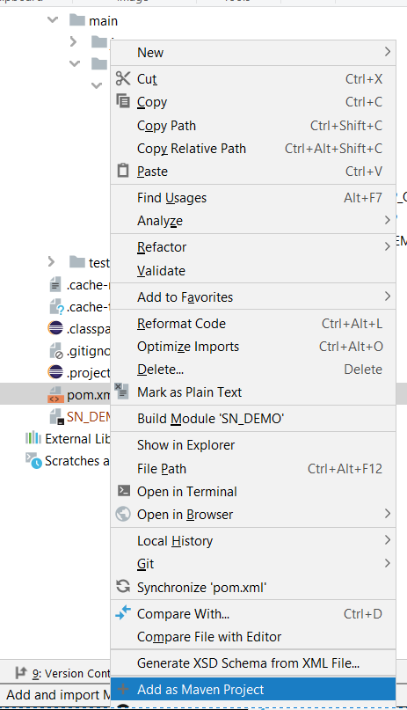

If prompted, click on **recreate**.

* Now go to File -> Project Structure. Here in Project SDK correct version of JDK should be selected.

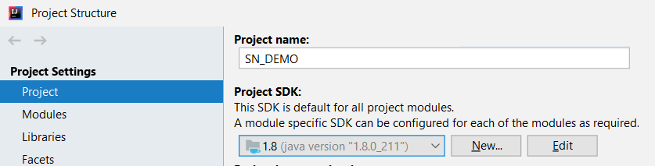

* Click on Libraries and add Scala SDK.

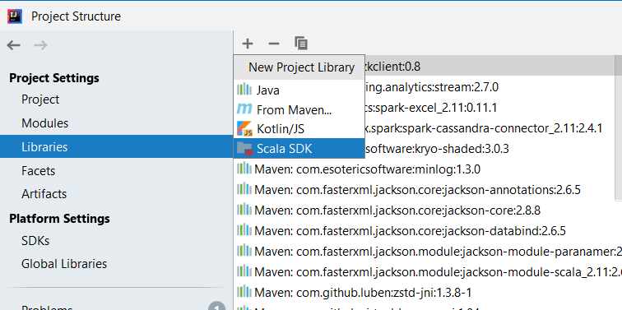

Choose the correct version (in this case 2.11.8) and click ok.

* Next, select File -> Settings -> Build,Execution,Deployment -> Build tools -> Maven and make sure following check boxes are ticked.

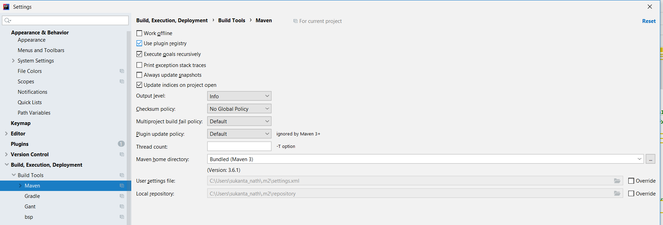

Click Apply and OK.

* Now, come back to editor, right click and run the program.

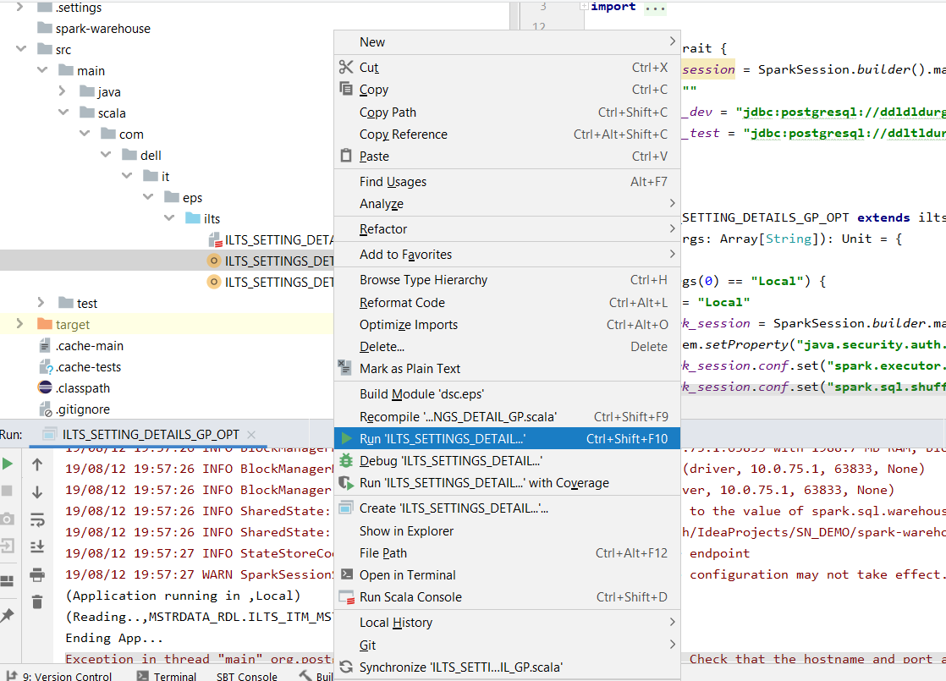

**Make Changes in code and push to Gitlab-**

To be continued….